Node Js Application Deployment

Create a Node js application.

Copy that weather application in another folder.

1. Go to github.com and create your account. If you have then login.
2. Create account on <https://id.heroku.com/login>
3. <https://devcenter.heroku.com/articles/heroku-cli#download-and-install>
4. Install Heroku CLI and check the version
5. heroku –v
6. To login on heroku using cli execute below command
7. heroku login
8. It will ask you to open browser, press any key to continue, complete the login, close the page and check cmd.

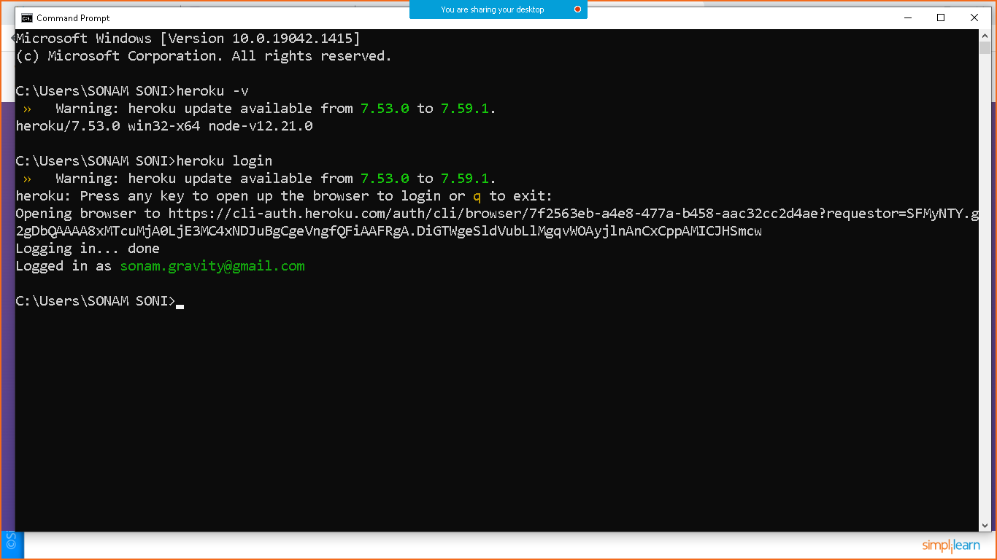

Let’s continue with Git

* Download git installer, install it and check the version
* git –version
* go to the application folder
* check whether application working fine or not
* create package.json file if it was not there.
* Execute npm install
* Create .gitignore file and add below code in that

node_modules/

* Now move to folder and initialize git repo.

git init

* git add .
* git commit –m “first commit”
* git branch –M
* git remote add origin paste-origin-link
* git push –u origin main
* upload code on git hub repo

Create Heroku app

* heroku create app-name

push github code to heroku

* git push heroku main

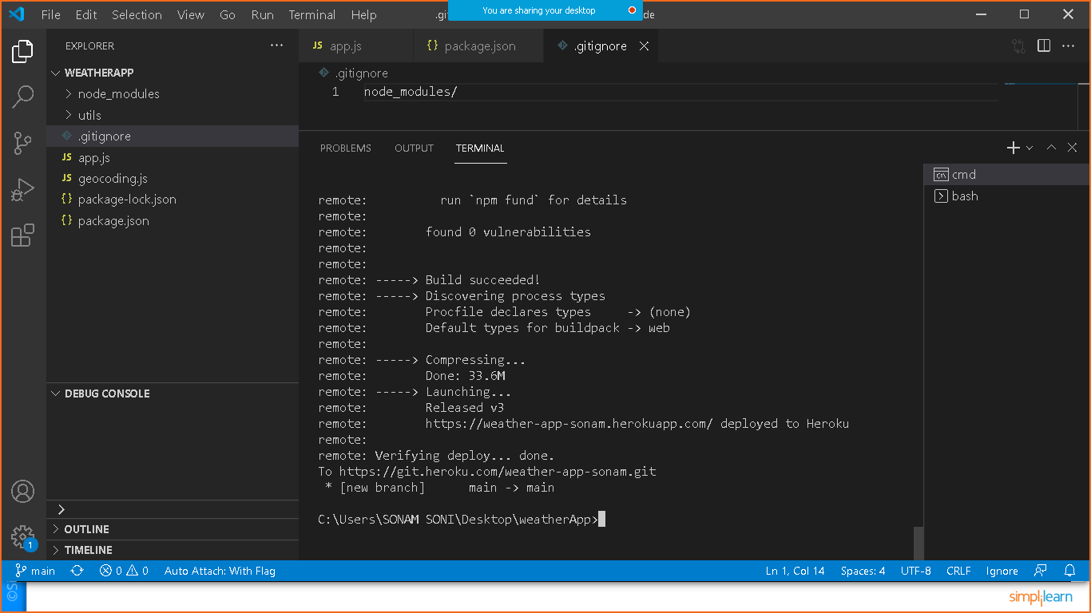

You can click on open app button to open app in browser.

You can share your code to everyone for access.